1. **OBJECTIVES**

See the requirements document

1. **HARDWARE DESIGN**

See the PCB Artist schematic file

1. **SOFTWARE DESIGN**

No change in software design (call graphs and data flow graphs are the same as those provided in the lab manual).

1. **MEASUREMENT DATA**
   1. **Show the data and calculated resolution, range, precision and accuracy**

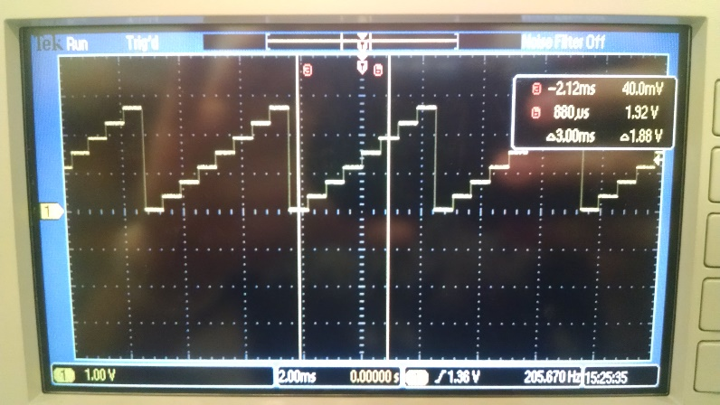

*Figure 1: Experimental measurement of the DAC output for 8 different digital inputs.*

*Our DAC’s actual output range is ~3 Volts. Our DAC seemed to output less voltage than expected for most of the tested values.*

|  |  |  |  |  |  |  |  |  |  |  |  |  |  |  |  |  |  |  |  |  |  |  |  |  |  |  |  |  |  |  |  |  |  |  |  |  |  |  |  |  |  |  |  |  |  |  |  |  |
| --- | --- | --- | --- | --- | --- | --- | --- | --- | --- | --- | --- | --- | --- | --- | --- | --- | --- | --- | --- | --- | --- | --- | --- | --- | --- | --- | --- | --- | --- | --- | --- | --- | --- | --- | --- | --- | --- | --- | --- | --- | --- | --- | --- | --- | --- | --- | --- | --- |
| |  |  |  |  |  |  |  |  |  |  | | --- | --- | --- | --- | --- | --- | --- | --- | --- | --- | | Digital Input | 0 | 512 | 1024 | 1536 | 2048 | 2560 | 3072 | 3584 | 4096 | | DAC Measured Output (V) | 0.07 | 0.43 | 0.81 | 1.19 | 1.57 | 1.93 | 2.3 | 2.68 | 3.05 | | Expected Output (V) | 0 | 0.4125 | 0.825 | 1.2375 | 1.65 | 2.0625 | 2.475 | 2.8875 | 3.3 | | Delta = Actual - Expected | 0.07 | 0.0175 | -0.015 | -0.0475 | -0.08 | -0.1325 | -0.175 | -0.2075 | -0.2467 | |  |  |  |  |  |  |  |  |
|  |  |  |  |  |  |  |  |  |
|  |  |  |  |  |  |  |  |  |
|  |  |  |  |  |  |  |  |  |

**Range:** 0 to 3.3V

**Precision:** 4096

**Resolution: (**range / precision) = 0.81mV

**Accuracy:**

**4.2 Show the experimental response of DAC including SNR**

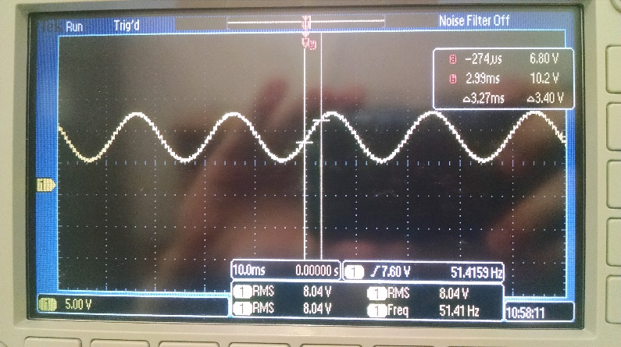

*Figure 2: Time domain of a sine wave at 51.5 Hz*

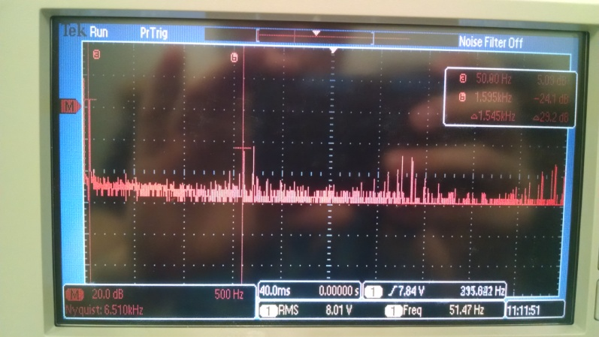

*Figure 3: Frequency domain of the same sine wave*

**Signal**: 5.05dB

**Noise**: -24.5dB

**SNR**: 27.55dB

**4.3 Show the results of the debugging profile**

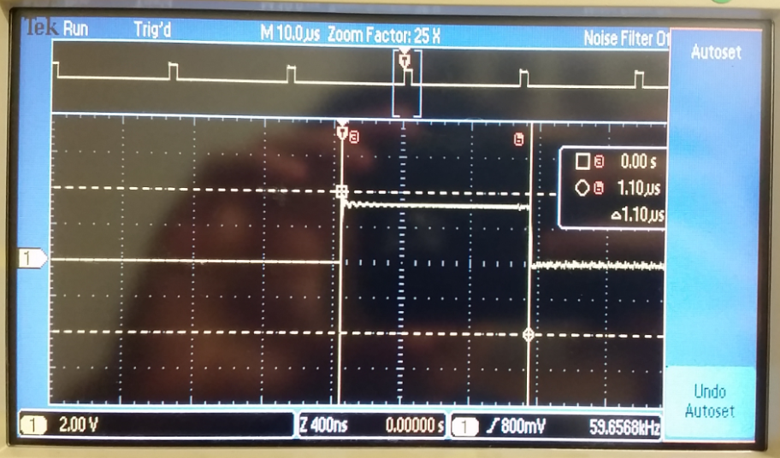

*Figure 4: This ISR shows the time it takes to output to the DAC (~1 microsecond)*

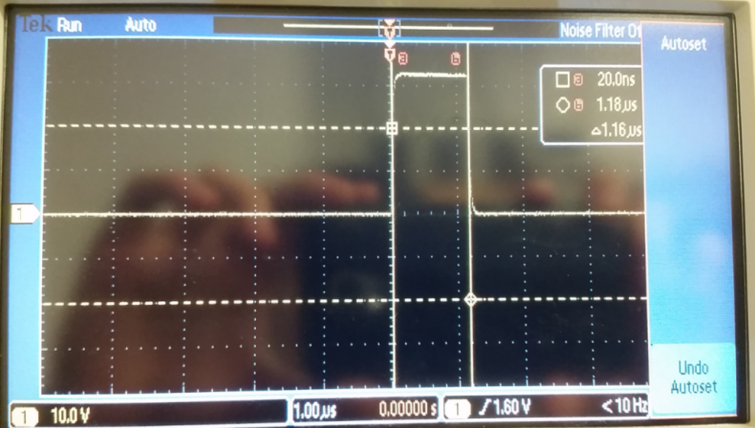

*Figure 5: This ISR shows the time it takes to change the tempo.*

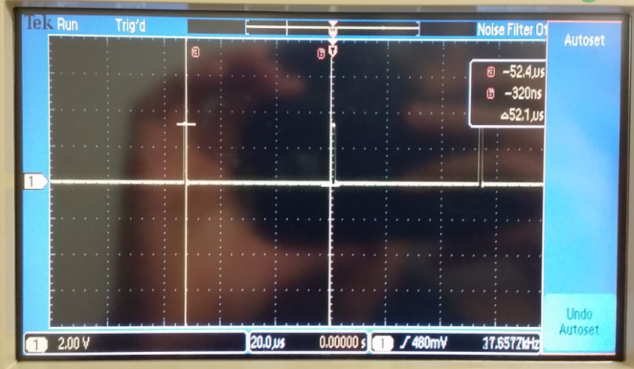

*Figure 6: The time between interrupts.*

**4.4 Measurements of current required to run the system, with and without the music playing**

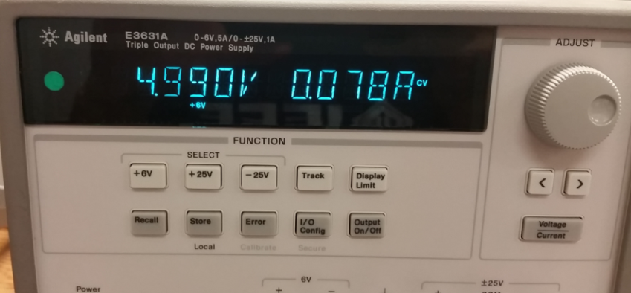

*Figure 7: about 78 mA was required to run the system without music playing*

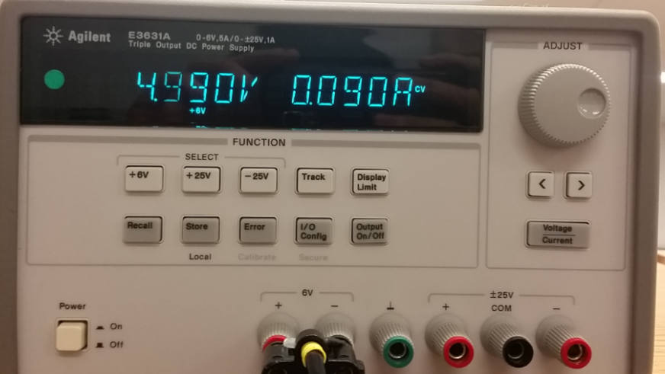

*Figure 8: about 90 mA was required to run the system with music playing;*

*this value did increase to 120-130 mA when playing louder music.*

1. **ANALYSIS AND DISCUSSION**
   1. **Briefly describe three errors in a DAC**
2. Offset Error: The difference between the DAC output and 0V when 0 is applied at the input.
3. Full-scale Error: The difference between ideal and actual DAC output when max input is applied. Very dependent on Vref stability.
4. Gain Error: Full-scale Error minus Offset Error. Deviation of input to output slope from ideal value.
5. We could also get errors from not sampling fast enough, our DAC might not have enough precision, our sine table might not have enough values in it, etc.
   1. **Calculate the data available and data required intervals in the SSI/DAC interface. Use these calculations to justify your choice of SSI frequency**

Highest Possible Frequency Note: B8 (7902Hz)

Sine Wave Precision: 64

Maximum "DAC_Out" per second: ~500,000

By Nyquist Theorem, Minimum sample rate: 1MHz

By Valvano's Theorem, Minimum sample rate: 5MHz

We chose 5MHz for the SSI clock because it is below the maximum for the DAC (20MHz) and a fraction of the bus clock (80MHz). Using a lower SSI frequency will use up less power anyway.

* 1. **How is the frequency range of a spectrum analyzer determined?**

The frequency range of a spectrum analyzer is dependent on the center frequency of the internal IF filter and the range of the local oscillator. It is defined as the Span on the analyzer's datasheet

* 1. **Why did we not simply drive the speaker directly from the DAC? What is the purpose of using the TPA731?**

Output from the TM4C is converted into voltage by the DAC, but the speaker needs a lot of current. The max current the TM4C can source is 8ma so we use the amp to not only convert the voltage into current, but to also boost it to an amount that can drive the speaker.